Data Analysis- Coffee_Shop_Sales Analysis

--Create a database

create database coffeedb;

--Import data in MySQL database

--Clean the data in MySQL

alter table Coffee_Shop_Sales

Modify Column Transaction_id int;

Modify Column Transaction_date date;

Modify Column Transaction_time time;

# Data Analysis based on problem statement

--calculate the total sales for each respective month

select

concat(round(sum(transaction_qty * unit_price)/1000,1),'K') as Total_sales

from Coffee_Shop_Sales

where month(transaction_date) = 1 -- Jan Month, respectively 2 Feb, 3 Mar.....

;

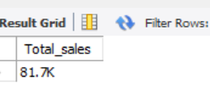

--Month on Month increase and decrease in sales Percent

select month(transaction_date) as Month,

concat(round(sum(transaction_qty * unit_price)/1000,1), 'K') as Total_sales,

(sum(transaction_qty * unit_price)- lag(sum(transaction_qty * unit_price),1)

over(order by month(transaction_date))) / lag(sum(transaction_qty * unit_price),1)

over(order by month(transaction_date)) * 100 as MoM_increase_Percentage

from

Coffee_Shop_Sales

where month(transaction_date) in (1,2) -- for Jan and Feb, Respectively 3 Mar,…….

group by month(transaction_date)

order by month(transaction_date);

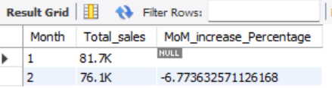

--Sales diff between selected month and previous month

select month(transaction_date) as Month,

concat(round(sum(transaction_qty * unit_price)/1000,1), 'K') as Total_sales,

sum(transaction_qty * unit_price)- lag(sum(transaction_qty * unit_price),1)

over(order by month(transaction_date)) as Sales_Diff

from

Coffee_Shop_Sales

where

month(transaction_date) in (1,2) -- for month of Jan and Feb

group by

month(transaction_date)

order by

month(transaction_date);

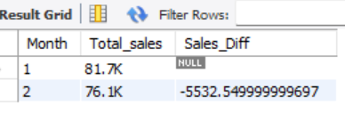

--Total orders in each respective month.

select

count(transaction_id) as Total_order

from

Coffee_Shop_Sales

where month(transaction_date) = 1; -- for Jan

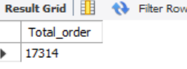

-- Month on Month increase and decrease in Orders Percent

select month(transaction_date) as Month,

round(count(transaction_id),1) as Total_Orders,

(count(transaction_id) - lag(count(transaction_id),1)

over(order by month(transaction_date))) / lag(count(transaction_id),1)

over(order by month(transaction_date))*100 as MoM_order_increase_percentage

from

Coffee_Shop_Sales

where

month(transaction_date) in (1,2) -- for Jan and Feb, Respectively 3 Mar,…….

group by

month(transaction_date)

order by month(transaction_date);

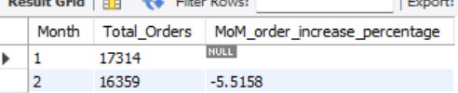

-- Orders diff between a selected month and the previous month

select month(transaction_date) as Month,

round(count(transaction_id),1) as Total_Orders,

count(transaction_id) - lag(count(transaction_id),1)

over(order by month(transaction_date)) as Order_Diff

from

Coffee_Shop_Sales

where

month(transaction_date) in (1,2) -- for Jan and Feb

group by

month(transaction_date)

order by month(transaction_date);

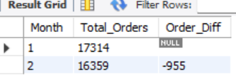

--Total Qty sold for each respective month

select sum(transaction_qty) as Total_Qty_Sold

from Coffee_Shop_Sales

where month(transaction_date) = 3; -- for Mar, Recpectively 1 for Jan,......

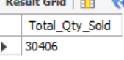

-- Month on Month increase and decrease in Sold Qty Percent

select month(transaction_date) as Month,

round(sum(transaction_qty),1) as Total_Orders,

(sum(transaction_qty) - lag(sum(transaction_qty),1)

over(order by month(transaction_date))) / lag(sum(transaction_qty),1)

over(order by month(transaction_date))*100 as MoM_sold_qty_increase_percentage

from

Coffee_Shop_Sales

where

month(transaction_date) in (1,2) -- for Jan and Feb, Respectively 3 Mar,…….

group by

month(transaction_date)

order by month(transaction_date);

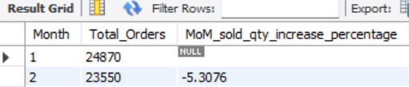

-- Oty Sold diff between a selected month and the previous month

select month(transaction_date) as Month,

round(sum(transaction_qty),1) as Total_Orders,

sum(transaction_qty) - lag(sum(transaction_qty),1)

over(order by month(transaction_date)) as MoM_Qty_Sold_Diff

from

Coffee_Shop_Sales

where

month(transaction_date) in (1,2) -- for Jan and Feb, Respectively 3 Mar,…….

group by

month(transaction_date)

order by month(transaction_date);

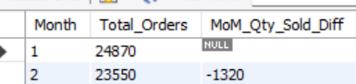

--Determine the Sales, Order, and quantity sold over specific day

select

round(sum(transaction_qty * unit_price),1) as Total_Sales,

count(transaction_id) as total_Order,

sum(transaction_qty) as Total_Sold_Qty

from Coffee_Shop_Sales

where transaction_date = '2023-03-12'

group by transaction_date;

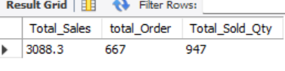

--Find the Sales performance on Weekdays and weekends

select

case

when dayofweek(transaction_date) in (1,7) then 'Weekends'

else 'Weekdays'

end as Day_Type,

concat(round(sum(transaction_qty * unit_price)/1000,1), 'K') as Total_Sales

from Coffee_Shop_Sales

where month(transaction_date) = 4 -- for April

group by case

when dayofweek(transaction_date) in (1,7) then 'Weekends'

else 'Weekdays'

end;

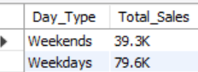

--Difference Between Weekdays and Weekends

SELECT

ROUND(SUM(CASE

WHEN DAYOFWEEK(transaction_date) IN (2, 3, 4, 5, 6) THEN transaction_qty * unit_price

ELSE 0

END), 2) AS total_weekday_sales,

ROUND(SUM(CASE

WHEN DAYOFWEEK(transaction_date) IN (1, 7) THEN transaction_qty * unit_price

ELSE 0

END), 2) AS total_weekend_sales,

ROUND(SUM(CASE

WHEN DAYOFWEEK(transaction_date) IN (2, 3, 4, 5, 6) THEN transaction_qty * unit_price

ELSE 0

END) -

SUM(CASE

WHEN DAYOFWEEK(transaction_date) IN (1, 7) THEN transaction_qty * unit_price

ELSE 0

END), 2) AS sales_difference

FROM

Coffee_Shop_Sales

WHERE

MONTH(transaction_date) = 4; -- for April, Respectively 1 for Jan,……

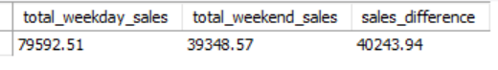

--Find the Monthly Sales by Store Location

select store_location,

Concat(round(sum(unit_price * transaction_qty)/1000,2),'K') as Total_Sales

from Coffee_Shop_Sales

where month(transaction_date) = 2 -- for Feb, Respectively 1 for Jan,.....

group by store_location

order by Total_Sales desc;

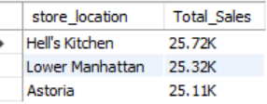

--Find the Daily Sales Average sales value

select round(avg(Total_Sales),2) as Avg_Sales

from

(select sum(unit_price * transaction_qty) as Total_Sales

from Coffee_Shop_Sales

where month(transaction_date) =3 -- For Mar, Respectively ! for jan,....

group by transaction_date) as internal_query;

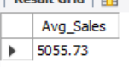

--Find the Daily sales for respective month

select day(transaction_date) as day_of_month,

round(sum(transaction_qty * unit_price),2) as Total_Sales

from Coffee_Shop_Sales

where month(transaction_date) = 5 -- for May, 1 for Jan,...

group by day(transaction_date)

order by day(transaction_date);

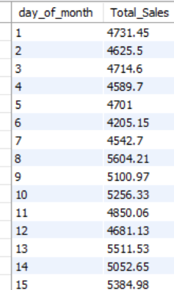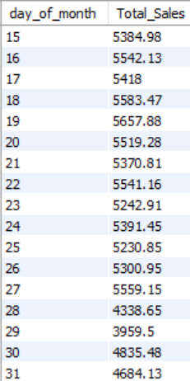

--Find the Product Category wise Sales

select product_category,

round(sum(transaction_qty * unit_price),2) as Total_Sales

from Coffee_Shop_Sales

where month(transaction_date) = 3 -- for Mar, 1 for Jan Likewise

group by product_category

order by Total_Sales desc;

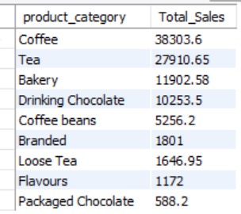

--Find the category that is contribute most sales value

select product_category,

round(sum(transaction_qty * unit_price),2) as Total_Sales

from Coffee_Shop_Sales

group by product_category

order by Total_Sales desc

limit 1;

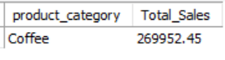

--Find the top 10 high-selling product

select product_Type,

round(sum(transaction_qty * unit_price),2) as Total_Sales

from Coffee_Shop_Sales

group by product_type

order by Total_Sales desc

limit 10;

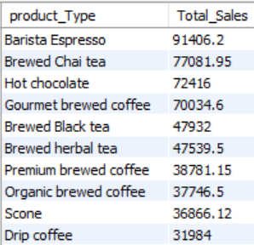

--Find the respective month sales on the basis of day and hours

select

sum(transaction_qty * unit_price) as Total_Sales,

sum(transaction_qty) as Total_sold_qty,

count(transaction_id) as Total_order

from Coffee_Shop_Sales

where month(transaction_date) = 4 -- April Month, likewise....

and dayofweek(transaction_date) = 2 -- Monday

and hour(transaction_time) = 6 --

;

